Towards a Panagogy
for Blended Learning Designs
Dr Anthony ‘Skip’ Basiel
[Proof read – find & replace ‘z’s for British spelling]
Contents
Abstract 1
Introduction 1
Learning Theory 1
Teaching Styles 1
Application 1
Proposal 1
Summary Discussion 1
References 1
Appendix 1

Abstract

Introduction
In his book Metaphysics, Aristotle, the ancient Greek philosopher, saw understanding how the world works as a basic human need. According to Du Sautoy (2016), the desire to know is programmed into the human psyche. Laurillard says that, ‘We have the ambition. We have the technology. What is missing is what connects the two (Beetham H 2007, p. xvi).’ This paper examines how we look at and understand the many ways humans grow through blended learning technology designs.
Think about a learning event which you have been actively involved with recently.
Was it a traditional academic classroom setting? Or did you attend a corporate training workshop? What are the profiles of the stakeholders in the learning event you have conjured up in your mind? Gender, age, computing capability, prior knowledge expertise? Recall the physical location. Was the seating in rows with a speaker in front? What media was used? Any video conferencing technology? What languages were involved? Was there a specific subject matter or problem that was addressed?
There are many elements to the choreography of this learning experience to consider. In this discussion we explore the epistemologies, instructional designs, strategies, and technologies that are part of pedagogy and andragogy as we work towards a ‘panagogy’ for blended learning solutions. Don’t fear, these academic terms will be explained.
As this discussion unfolds, it is easier to describe learning theories or designs in terms that place them on opposing extremes or either end of the spectrum. Kilgore (2021) refers to this as a ‘false binary’ where theory is used to define elements of practice, but the reality is actually a blend of theoretical components. The ‘Golden Mean’ was Aristotle’s expression for finding a balance in the extremes. This ‘mean’ could be applied in mathematic proportions in nature to philosophical positions. In our context, we find in any given learning case study a variety of learning perspectives and technologies. No single model meets all learners’ needs.
Let’s start with a core term – epistemology. One definition sees epistemology as ‘the philosophical study of the nature, origin, and limits of human knowledge. The term is derived from the Greek epistēmē (“knowledge”) and logos (“reason”), and accordingly the field is sometimes referred to as the theory of knowledge,’ (Britannica, 2021).
We might ask, ‘Is knowledge content or process?’ This ‘either-or’ comparison provides a good platform for debate, however, when applied to a real-world context, we may find that the example you envisioned earlier is somewhere on a ‘learning spectrum’ where the learning event has both content and process, but in varying degrees depending on the subject knowledge domain and situation. This paper aims to provide insight into our current teaching and learning models for face-to-face settings and adapt them for our blended learning experiences.
Forming a common language is a good starting place for this examination. There are many educational terms that we need to agree on their meaning so we can form contextualisation on our journey towards a unification of the various ‘-agogies’.
Analogue to augmented learning environments
Physical and virtual space is another part of this exploration. We will start with the analogue (‘real’) world learning environment using a ‘dead-tree’ format and move towards digital online representations (or augmented learning environments) of how learning might be perceived.
In person or face-to-face teaching and learning is our starting place. The TES Editorial (2018) gives us a view of the history of pedagogy. Socrates, in the 5th Century BC, is seen as the keystone of what we now consider to be modern education. Pedagogy is simply defined as the method, and practice, of teaching which encompasses teaching and learning theories and styles.
Beetham (2007) says pedagogy involves ways of knowing as well as ways of doing to create a dialogue between theory and practice (also known as ‘praxis’) as well as between teaching and learning. So let’s use a theatrical illustration. Pedagogy is not just the design or orchestration of the learning artifacts (props), stakeholders (players) and setting(s), but the choreography of the timing of each ‘act’ or pacing of the progression through the lesson content. After the introduction of the skill or concept, it then relies on the learners to apply the learning objective and demonstrate mastery of their capability.
Knowles (1984) emphasised that adults tend to be more self-directed and expect to take responsibility for decisions as compared to child-aged learners. Andragogy makes the following assumptions about the design of learning: Adults - (a) need to know why they need to learn something; (b) need to learn experientially; (c) approach learning as problem-solving; and (d) learn best when the topic is of immediate value. Because adults have more life experience or tacit knowledge than children, they can tap into prior knowledge as an inductive way of developing meaning making.
[ add Brian – knowing that v. how.
Ackuff R – data>info>know>wisdom, but experience? Learning is about acquiring perspectives, not just more content.]
[ Add – Mobious strip learning ]

Learning Theory
Our position in the introduction was that we would discuss opposing issues and views to help us contextualise the ideas and systems so we could apply them to our own situation. In this section we explore two leading learning theories for your analysis: Behaviourism and Constructivism.
Behaviourist Learning Theory
Whereas a behaviourist would continue to look at the content to be learned and the influence of the environment upon that learning, a constructivist would be more interested in knowing how the learner is attempting to construct meaning (Bush, 2006).
“The behaviorism of Watson and Skinner is based on a positivistic approach to science, that is, a reductionist view in which all that can be addressed is the relation between sensory stimuli and the unique corresponding response” (Webb, 2007, p. 1086). However, Skinner eventually came to the realization that human beings go beyond just responding to the environment. He found that they also react to the environment based on prior experiences (Skinner, 1974).
An example of how the Teaching Machine was used is described by Skinner (1958) as follows: “In using the device the student refers to a numbered item in a multiple-choice test. He presses the button
corresponding to his first choice of answer. If he is right, the device moves on to the next item; if he is wrong, the error is tallied, and he must continue to make choices until he is right” (p. 971). Though basic, it is easy to see the similarity between the teaching machine and many of today’s educational software programs. Like the teaching machine, computer software designed for students help to reinforce student behavior.
Robert Gagne’s early work focused on behaviorism with special attention being given to military training. This notion of order, of drill and practice in the military is very much what modern day instructional computer programs look like. In an online learning environment, behaviorism involves chunking curriculum into smaller instructional steps. These smaller more manageable steps can then be repeated with ongoing monitoring of student learning.
Constructivist Learning Theory
Constructivists believe that learners develop knowledge through active participation in their learning. the primary role of the teacher should be to motivate the children to create their own knowledge through their personal experiences (Rummel, 2008).
Note add to my conclusion table of Panagogy principles - teaching style. lecturer / facilitator , presenter / moderator
also - knowing facts / searching online well
Also - stakeholder orientation / multimedia interactive inductions
Hypermedia and multimedia are examples of online instructional approaches that are more constructivists in nature and have resulted in an emphasis on problem solving for students.

Teaching Styles
[ add need to learn how to Present online and use text chat to promote learning engagement]
Schools appeared in England as early as 597 AD, and it is generally believed that the first school in England was King’s School in Canterbury, Kent. The content of the curriculum could be split into two sections: Trivium (grammar, rhetoric, logic) and Quadrivium (arithmetic, astronomy, geometry, music). Lessons took the form of a lecture, with a teacher leading the students whilst they read, explaining the texts. Then the students were given questions that they argued through the answers amongst themselves, then with opponents a little senior, before they finally engaged with the masters who had taught them (TES 2018).
<Confirm if this goes here> Schools of thought - epistemologies
Four well known philosophical schools of thought are idealism, realism, pragmatism, and existentialism.
Each of the aforementioned philosophies has implications for education. The idealist is idea centered rather than subject or child centered. The idealist believes that the teacher is central to learning. Therefore, the idealist tends to emphasize lecture, discussion, and imitation. The realist sees the role of the teacher as a person who presents content in a systematic and organized way. Contemporary realists are behind standardized tests, serialized textbooks, and specialized curriculum for each discipline. The pragmatist stresses applying knowledge—using ideas for problem solving. Realists and idealists are most closely associated with the behaviorist’s theory of learning, because they believe in a standardized curriculum centered on academic disciplines.
Pragmatists prefer a curriculum that is interdisciplinary, and they are, therefore, most closely associated with the constructivists’ beliefs about how students learn best (Johnson et al., 2008).
[ Brian – Systems: biological / organisational-cultural / technical
Research – not just find an answer > find better questions
Innovation – happens in the space between people > no in the heads of smart people.[
[ Learning Entropy – from book chapter
A weakness of this open discussion model is that it can become chaotic. The Live Host/Local Facilitator can juggle the flow of the interactions, but the larger the audience the more difficult it is to choreograph the webinar event. Let us look at a physics principle called entropy(2020) to guide us through the webinar mayhem. Simply put any system will tend towards disorder, rather than a systematic structure. For example, if I have a container with 20 game dice that I throw across the table, the grouping patterns will be random, not tidy. The probability of the dice forming a pyramid is very low. Instead, there may be no evident pattern. Some of the dice may cluster together, while others are isolated. ‘Learning entropy’ in a webinar is manifested by the unstructured nature of brainstorming. The creative process can be steered by the Host/Presenter through the technical features of the webinar such as limiting participant video and audio transmission. Questions and comments can be redirected into the live text chat, but that too can become chaotic in mass volume.
Is there a way to funnel the interactions of the webinar without forcing too much control from the event organisers?
A fishbone or Ishikawa diagram (2020) offers a way to conduct a cause and effect analysis for a brainstorming session. Cause and Effect Analysis gives you a useful way of doing this. This diagram-based technique combines brainstorming with mind mapping to consider all possible causes of a problem, rather than just the obvious ones. According to Mindtools.com (2020), ‘When you have a serious problem, it's important to explore all of the things that could cause it, before you start to think about a solution. Then, you can solve the problem completely, first time round, rather than just addressing part of it and having the problem run on and on.’ A fishbone diagram can:
- Discover the root cause of a problem,
- Uncover bottlenecks in your processes,
- Identify where and why a process isn't working.
Step 1: Identify the problem.
This may use a Soft Systems Methodology technique (SSM) from Checkland (2012) called CATWOE where you look at the problem from the perspective of Customers, Actors in the process, the Transformation process, the overall World view, the process Owner, and Environmental constraints.
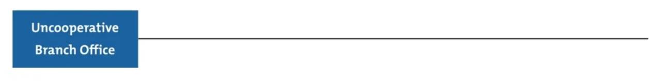
Figure 3 Fishbone Diagram - Identify the problem Mindtools.com
Step 2: List major factors
Next, identify the factors that may be part of the problem. These may be systems, equipment, materials, external forces, people involved with the problem, and so on.
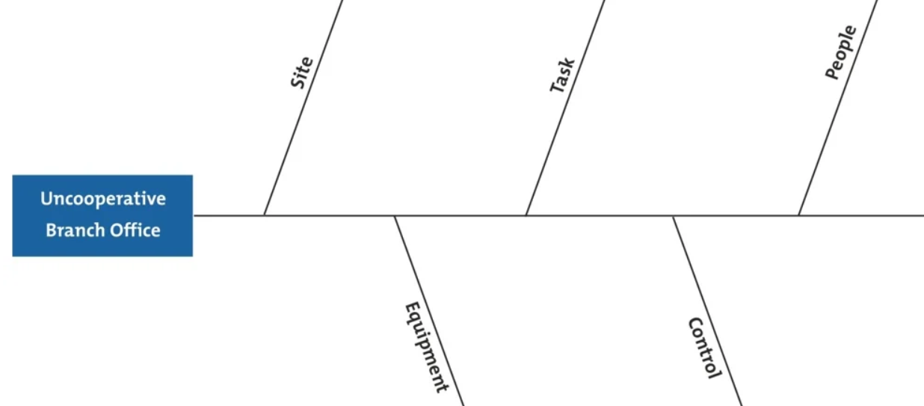
Figure 4 Step 2 Fishbone diagram - Major Factors
Step 3: Possible causes
Now, for each of the factors you considered in step 2, brainstorm possible causes of the problem related to the factor.

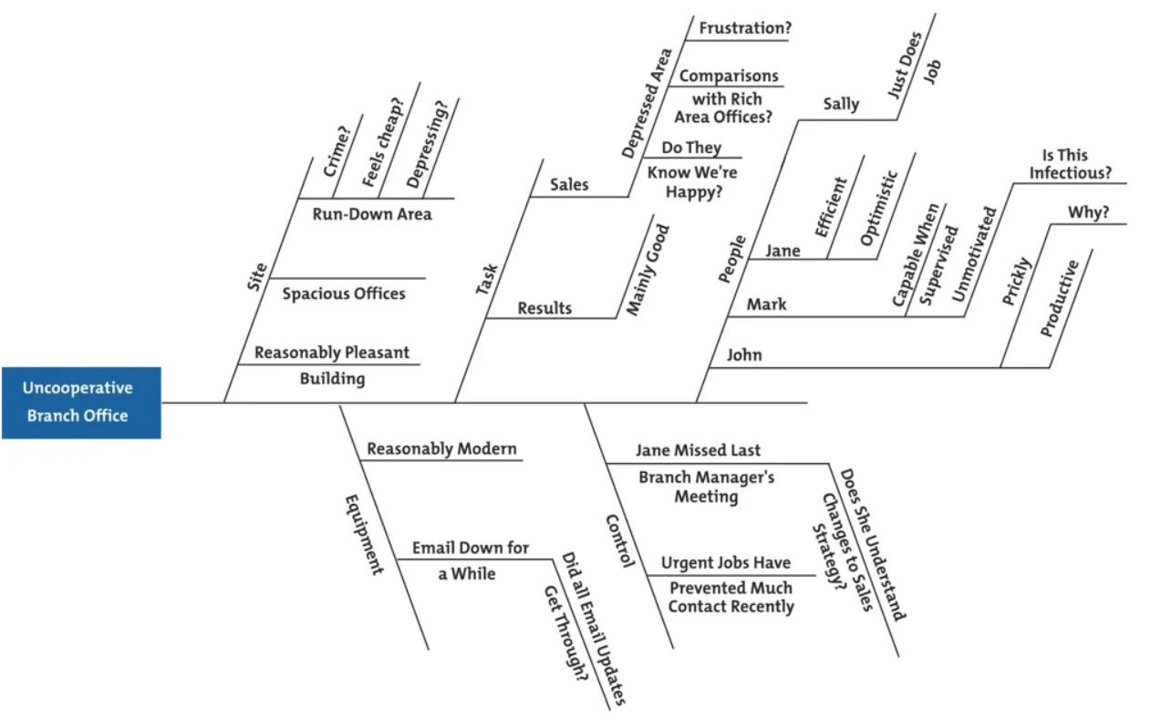
Figure 5 Step 3: Possible causes.
Step 4: Analyse the problem
Analysis may involve setting up investigations, carrying out online surveys, web video conference interviews. These techniques test which of these possible causes is actually contributing to the problem and provide evidence to inform action. In the context of the Transactional Webinar Design, analysis may take place during one event or over a series of webinars.
In the example presented in the figures above the manager may have assumed that people in the branch office were "being difficult." Instead, he thinks that the best approach is to arrange a meeting with the Branch Manager. This would allow him to brief the manager fully on the new strategy, and talk through any problems that she may be experiencing.

Analysis Framework (Basiel A. (2020a) – 70:20:10 Webinar Design
A ‘fishbone diagram’ or Ishikawa (1968) cause and effect tool is one technique to provide a framework towards directing a webinar brainstorming session to find a resolution. In Figure 4, we start with the problem, or ‘effect’, of improving webinar engagement [Start Problem #1]. Next, we examine the elements causing the problem [Why 2]. From this level, we can provide a more detailed analysis towards a possible conclusion [What to do #3]. In this sample, we may suggest that the Technical Support and Instructional Design Team offer training to Tutors and Students on Microsoft Teams while working from home during the coronavirus. The webinars may start as traditional Lectures with Q&A at the end, but develop into more interactive pedagogical designs linked to learning resources in the LMS. Monitoring attendance and assessment provides data for further webinar design improvements towards engagement.
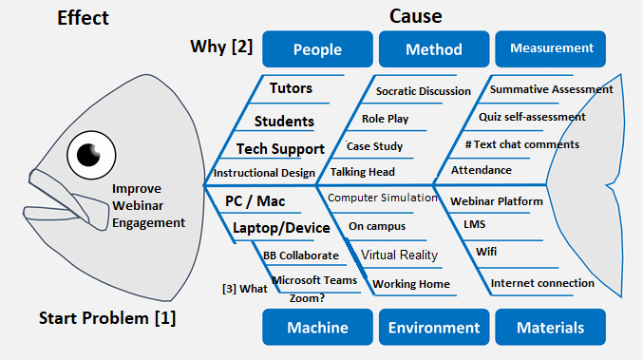
]
The QAA (2021) (Quality Assurance Agency) for the UK provides a framework for modern curriculum and higher education processes. A quantified system is used to identify measurable learning objectives for each subject specialism. These may be mastery of an abstract concept or demonstration of a skill or capability. The level of competency varies on the year within the degree programme. Evidence is provided through an assessment to validate the learner’s comprehension or ability to perform a task.

Application
BEETHAM NOTES:
Adapted from (p7) Beetham. Design is a term which bridges theory and practice. Blended learning design applies a praxis model to become a paradigmatic discipline for the digital age. This blended learning process involves four stages:
Investigation Stage:
The learning designer establishes profiles for the stakeholders to identify the factors that may impact on the blended learning event (e.g. age, prior experiences, English language capability, etc.). This profiling exercise needs to be done for each cohort or instantiation of the eLearning event to provide a foundation from which to build the blended learning strategy. The first step of the learning architecture is to have an agreed ‘telepistemology’ (the way knowledge is viewed in the blended learning context). Next, the blended learning theory guides the choice of technology. As part of the technology plan, a clear file management structure and file-naming system is needed to have consistency between the front-end, or user interface of the Learning Management System (LMS) and the back-end file resources (Learning Interventions: e.g. lecture PowerPoint slides, videos, exercises, etc.)
Application Stage:
When the learning theory is established it identifies the design principles to be applied to the curriculum and learning event development. The application of these blended learning design principles over time establishes a series of pilot case studies. The patterns established from these blended learning models work towards establishing eLearning ‘case laws’. A case law uses the detailed facts of a legal court case that has been resolved by courts or similar tribunal to provide benchmarks that can be applied to future case samples. A precedent, known as stare decisis, is a history of judicial decisions which form the basis of evaluation for future cases. Common law, also known as case law, relies on detailed records of similar situations and statutes because there is no official legal code that can apply to a case at hand. In a blended learning context, we look at the ‘learning cases’ to establish design principles to support our design decisions.
Representation / Modelling Stage:
Is there a ‘best fit’ design? What are the risks? Where can the design fail? Are there alternatives or back-up plans in place? As with any human system or project design, it is necessary for the agents or stakeholders to communicate and collaborate. What is the communication strategy for the blended learning system? What tools will be explicitly used by the actors of the learning event?
Evaluation and Iteration
During and after the event it is vital to collect data from the stakeholders to determine if the project / blended learning event met the SMART objectives. From this data we can fathom answers to questions like; ‘What changes are needed?’, How useful was the learning event in practice (a real-world context)? Is it possible to design and provide learning templates? In this context a learning template may be an assessment report Word document that has standardised section titles so the student can focus on the content for each section. This type of learning template provides consistency to all submissions.

Principles of Panagogy: Core Learning Design
Intentional – Start with a SMART measurable objective
Systematic – The blended learning design can be replicated (and adapted if need be) for different cohorts or knowledge domains.
Responsive – The blended learning design needs to be able to adapt to meet the stakeholders’ needs. The eLearning system can not be static.
Accessible – The blended learning system needs to be available to as many stakeholders’ profiles as possible. The design needs to be open and inclusive. Here are some guidelines:
- Provide enough contrast between text and background colour. ...
- Use more than colour to indicate important information. ...
- Write good alt text for your images. ...
- Use focus states. ...
- Make descriptive links. ...
- Provide captions and descriptions of video. ...
- Provide cost-accessible options of your designs.
( automatic design 2019)
Creative – The blended learning designer needs to be open to innovation and the unexpected.
Jochems et al (2004) sees learning design as a discipline in its own right. , with its own specific processes and modelling language.
Jochems W. (2004), ‘Integrated e-Learning: Implications for Pedagogy, Technology and Organisation.’ Taylor Francis, London. Learning design is moving from instructional design with a focus on the eLearning events as a set of generic activities to be instantiated in a particular context.
Panagogic Principle Guide
Mays T (2007) in Betham (2007) reminds us that ownership of the learning experience is also a core principle for the derivation of the meaning and the construction of the derivation of meaning and to construction of knowledge.
Learning outputs from the stakeholders in a blended learning event moves it to a Web 2.0 learner-generated content design.
Motivation (Betheem p 30) is another core element. Learners must be interested in achieving the learning outcomes. Traditional external learning outcomes are set by the university curriculum designer for validation by the External Examiner in the Quality Assurance process in the UK for the Programme and the Module. A work based learning model has the candidate set an individualised learning programme plan through a foundation of knowledge and skills established in an APL (accreditation of prior learning) portfolio.
Principles of Panagogy in Blended Learning Design
Face-to-Face Element | Panagogy principle
Epistemology | Telepistemology
Learning as content / through resources | Learning as process
Procedural knowledge | Open-ended problem solving
Information as facts | ‘Fuzzy facts’
Analogue Learning Theory | Blended Learning Theory
Behaviourist learning theory | Web-constructivism
Skill development | Conceptual mastery
Formal learning | Informal learning
Classroom / Training room | Everywhere / mobile learning space
Text-based resources | Multi-media
Teacher-generated content | Web 2.0 Learner-generated content
Learning in isolation (individual) | Social networked learning model
Establish a study partner / group | Virtual study collaboration
Learning through set-outcomes | Work-based learning individual outcomes
Analogue Teaching Styles | Blended Teaching Styles
Lecture with PowerPoint with students sitting in rows | More of a story telling approach to have stakeholders share experience and knowledge
Lecturer uses mostly statements for instruction | Questions lead a dialogue promoting learner-generated content
Raise hands for Q&A at the end | Text chat questions are posted throughout the discussion to create new branches / threads for the narrative to grow.
Guest Speakers in person | Webinar Guest Speakers
Recordings capture presenter and slide deck | Webinar recordings contain closed captions, text Q&A with participant videos
FAQ from transcripts | Dynamic FAQ from text chat
Self-assessment quiz – formative feedback | Student-generated MCQ questions with student answers and evidence links.
Analogue assessment presentations, paper-based exams, etc. | Virtual eAssessments submitted online. Digital essays, web video presentations and recordings.
Assessment feedback review in class lecture | Blended 360* Socratic discussion peer review with recording for reflection

Beetham (2007) – Topology – pg 123 – add to this for critical review [ organise table elements by themes ]

Proposal
The next stage of this research is to build an application to support blended learning stakeholders. This paper has set a theoretical foundation for moving from a face-to-face setting to a blended / eLearning context. I have designed and developed online education toolkits in the past. Below are several samples of putting the eLearning theories and designs into practice.
The 70:20:10 Webinar Design Paper (Basiel A 2020) looks at using informal learning in our blended solutions. The online toolkit is based on Moore’s Transactional Distance Theory to provide the webinar host/presenter with a profile of various elements of engagement to work towards more interactive learning opportunities.
The Virtual Learning Environment (VLE) Toolkit (Basiel 2007) examines elements that comprise an online learning management system. This online profile toolkit creates a graphic representation of eContent, eCommunication, eLearning Theory and file management.
Finally, the Flat-pack webinar design toolkit (Basiel 2019) offers a checklist of items for the webinar host/presenter using the PAP (Pre-At-Post) model. The guidelines include webinar factors such as project management, business / marketing plans, instructional designs, technology suggestions, etc.
This paper serves as the foundation to build a mobile application to provide blended learning stakeholders support in the research and development of powerful in/formal opportunities.

Summary Discussion
[ add]

References
Basiel A. (2020a), ’70 :20 :10 Webinar Design’, https://docs.google.com/document/d/1_TXqkLqT5yhNWbtSWrJde0aQr2nIxy-m/edit?usp=sharing&ouid=115658292435481901964&rtpof=true&sd=true
Basiel A. S. (2020), ‘Transactional Webinar Design‘. https://drive.google.com/file/d/1W-ps95oELnKXXsydehI8WAB5-MMccaTm/view
Sutton B. (2021), ‘What is Leadership and Learning Webinar: Life Reflections’, https://youtu.be/yLba8K3-Zag
Weegar M. (2012), ‘A Comparison of Two Theories of Learning -- Behaviourism and Constructivism as applied to Face-to-Face and Online Learning’, E-Leader Manila
Knowles, M. et al. (1984). Andragogy in Action. Applying Modern Principles of Adult Education. San Francisco Jossey-Bass.
Automatic Design (2019) https://automattic.design/inclusive/
Basiel A (2007). ‘ePedagogy for Virtual Learning Environments’ https://drive.google.com/file/d/1KLqvTlq0dzuGZ2xosUSxiglx2GDiCpaV/view
VLE Toolkit https://drive.google.com/file/d/0B5KEPSFKjo5OOXFKYlplRjBBZjQ/view?resourcekey=0-hypdvAJnY-f1UPTyP6h_og
Basiel A (2019) Flat-pack webinar design toolkit, https://drive.google.com/file/d/1cH2OQv31Tsrx-MxhfTbHNMgmnRBQpEhL/view
Basiel A (2020) https://docs.google.com/document/d/1_TXqkLqT5yhNWbtSWrJde0aQr2nIxy-m/edit?usp=sharing&ouid=115658292435481901964&rtpof=true&sd=true
Online 70:20:10 toolkit - https://abasiel.wordpress.com/awards/
Beetham H (2007), ‘ Rethinking Pedagogy for a Digital Age’, Routledge Press, Oxon
Britannica (2021) https://www.britannica.com/topic/epistemology
Du Sautoy M (2016), ‘What we can not know’, Harper Collins, London
Kilgore W. (2021), iDesign Webinar 21 September 2021 – https://vimeo.com/611373367/dc4fa7fd01?utm_medium=email&_hsmi=162457672&_hsenc=p2ANqtz-_Wy9cpuj5ycoosWpexb6_Rcu7lu_1kqPmEzDqbaPwH5-eZcme6OXIwzSEJuYetp1lzHnXINZeS_ukNlAp1YL_xqAyydg&utm_content=162457672&utm_source=hs_email
Makhlouf J (2019) https://elmlearning.com/pedagogy-vs-andragogy/
QAA (2021) https://www.qaa.ac.uk/quality-code/qualifications-frameworks
Tes Editorial (2018) https://www.tes.com/news/what-is-pedagogy-definition
Weegar M. (2012) ‘A Comparison of Two Theories of Learning: Behaviorism and Constructivism as applied to Face-to-Face and Online Learning https://g-casa.com/conferences/manila/papers/Weegar.pdf

Appendix

https://www.youtube.com/watch?v=x5L3dVGJRoA
[ NOTE – ADD my PRAXIS paper from wordpress ]
https://www.quora.com/What-is-entropy-4

