 | 

Social Media Marketing
Learning Activities 12 February 2016
Presenters:
Anthony Basiel,
anthony.basiel@gsm.org.uk
Sam Koolmon
sam.koolmon@gsm.org.uk

For today’s workshop there will be three Social Media Marketing activities:
- Learner-generated quiz
- Peer-to-peer customer testimonial YouTube video
  - Student voting review
- Business Scenario – analysis and discuss
At the end of these activities learners will be applying these concepts:
- From the content provided in the PowerPoint presentations students will make 3 multiple choice questions which will be used as a learner-generated review at the end of the lesson.
- Use YouTube to generate a web video testimonial for their business
- Provide a critical review the web videos presented in class
- Discuss and analyze a business scenario to provide an action plan for the company
Related resources:
Online Poll or Voting: https://www.polleverywhere.com/
Respond at PollEv.com/anthonybasie822
Text ANTHONYBASIE822 to 020 3322 5822 once to join
YouTube:
Record your own YouTube Videos
https://www.youtube.com/watch?v=Ntjle6tt_sI
Some examples:
http://wistia.com/blog/getting-started-video-testimonials
https://www.youtube.com/watch?v=WQW1jqPsyJ4
https://www.youtube.com/watch?v=AlPlXL3K-K0
https://www.google.co.uk/webhp?sourceid=chrome-instant&ion=1&espv=2&ie=UTF-8#q=good+examples+of+web+video+testimonials&tbm=vid

GSM Ethical Release Form
This form is to allow participants in the GSM workshop to video for academic / training purposes. This is not a commercial exercise. I give permission to record and publish the web video recording online.

Participant name: ________________________________________________________
Participant signature: _____________________________________________________
Date: ____ / ____ / ___________________

Social Media Workshop – Student Activity 1
Student generated quiz questions:
The purpose of this exercise is for the workshop participants to demonstrate their engagement with the content and discussion by producing end-of-class quiz questions which include the correct answer and supportive feedback for the correct solutions. Please complete the form below BEFORE the end of class and return it to the workshop Facilitator. Use the Quiz form to submit your solutions and mark your quiz.
Workshop participant name: ______________________________Date:_____________
Question 1: ________________________________________________________________________________________________________________________________________________________________________________________________________________________________________________________________________________________________________________
Answer A1: [Wrong/Correct]______________________________________________________
Answer A1: [Wrong/Correct]______________________________________________________
Answer A1: [Wrong/Correct]______________________________________________________
Correct answer feedback: _______________________________________________________
Question 2: ________________________________________________________________________________________________________________________________________________________________________________________________________________________________________________________________________________________________________________
Answer A1: [Wrong/Correct]______________________________________________________
Answer A1: [Wrong/Correct]______________________________________________________
Answer A1: [Wrong/Correct]______________________________________________________
Correct answer feedback: _______________________________________________________
Question 3: ________________________________________________________________________________________________________________________________________________________________________________________________________________________________________________________________________________________________________________
Answer A1: [Wrong/Correct]______________________________________________________
Answer A1: [Wrong/Correct]______________________________________________________
Answer A1: [Wrong/Correct]______________________________________________________
Correct answer feedback: _______________________________________________________

GSM Social Media Quiz Answer Sheet:

Workshop participant name: _______________________________________
Date of event: ____________________
Circle your answer below for each question. Select only one letter for each question.
Mark X if wrong and √ if correct.

Question 1: (A) (B) (C) Mark: ___

Question 2: (A) (B) (C) Mark: ___

Question 3: (A) (B) (C) Mark: ___

Question 4: (A) (B) (C) Mark: ___

Question 5: (A) (B) (C) Mark: ___

Total Correct Answers: ______/ 5 x 2 = ____%

YouTube Exercise
Here is a video to guide you in making your business YouTube web video testimonial social media eMarketing resource:
https://www.youtube.com/watch?v=Ntjle6tt_sI
Now identify who will be your project manager. Next, identify your work plan. You will only have one hour to storyboard, record and test your web video testimonial.
You can use the resources on the cover page to get some tips.

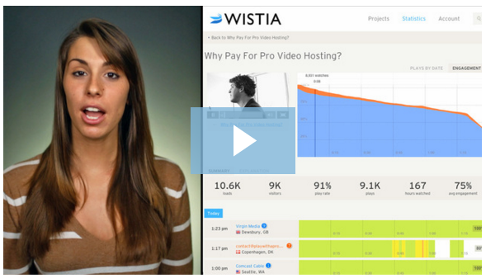

Polleverywhere: voting on workshop videos
Online Poll or Voting: https://www.polleverywhere.com/
Respond at PollEv.com/anthonybasie822
Text ANTHONYBASIE822 to 020 3322 5822 once to join – Then text only your letter rating:
A (very good), B (good) or C (fair)
CLASS VOTE:
- Log on or text your vote for video. We will look at the class response for the rating value.
- Next – We will have a class discussion to share your ‘friendly critic’ suggestions on how to improve the video testimonial.
Remember it is OK to make mistakes now – as it will not impact on your company performance. But take your lessons learnt to perfect your social media marketing skills, knowledges and capabilities.

Exercise 2: Scenario analysis
Below is a letter from the solicitor representing the client which was videoed in the first exercise. They wish to press a formal complaint against your company for posting their video on the internet without their written permission.
Your group task is to analyze the situation and establish:
- How you will react to the immediate situation
- What you could have done differently
- What suggestions you will put forward to the company to inform a social media strategy
~~~~~~~~~~~~~~~~~~~~~~~~~~~~~~~~~~~~~~~~~~~~~~~~~~~~~~~~~~~~~~~~~~~~~~~~.

 | Tough Guys Solicitors  222 You Will Be Sorry Rd.  London SW1 9ER

Dear Sir,
This letter is to inform you on behalf of my client, Mr. Bloggs, that we are bringing formal charges forward to your company with respect to the video you have posted on the internet.
This action is an infringement on my client’s privacy and is in breach of the UK law with respect to publishing images on the internet. (See http://www.publications.parliament.uk/pa/ld201415/ldselect/ldcomuni/37/3704.htm and http://findlaw.co.uk/law/consumer/other_consumer_law_topics/online-photograph-rights.html ).
We wish to arrange a meeting with a representative to formulate an appropriate form of compensation for the use of our clients video testimonial. If you are making a profit from this social media marketing we should be getting a commission.
We look forward to your timely response to avoid further legal action.
Respectfully submitted.
John Dowe
Attorney at Law
Tough Guys Solicitors

